ER Model Report
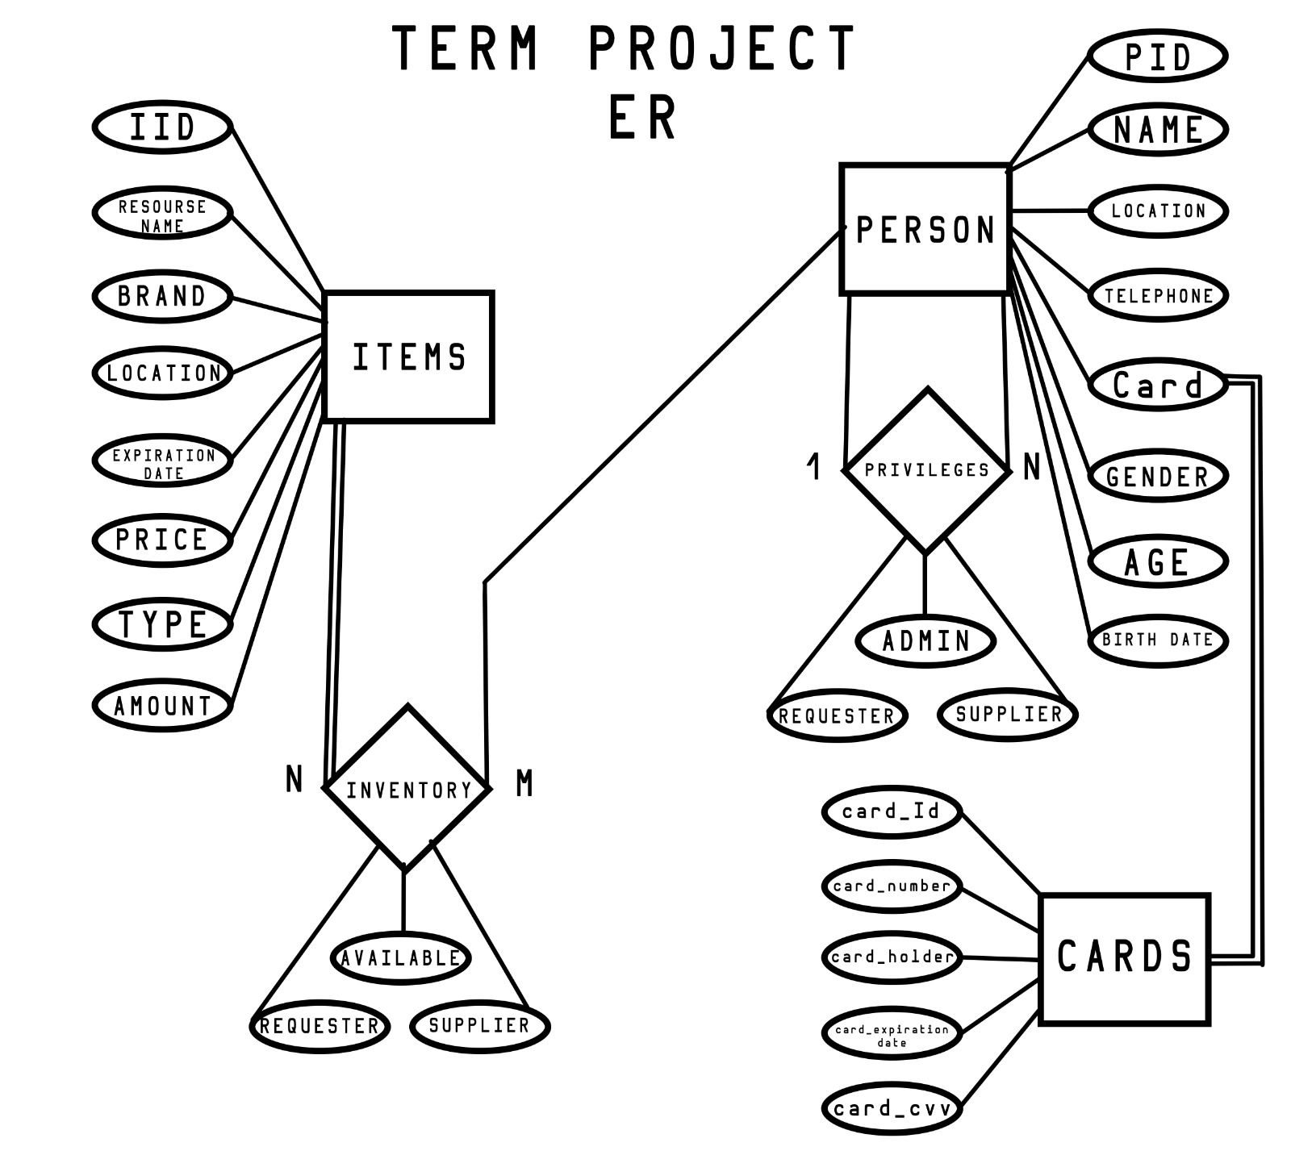
Entities
- Items – this represents the items that will be supplied/requested by the client.
Attributes
- IID – it identifies the different items uniquely
- resource name – this attribute represents the different items supplies. In this case these are water,medication,baby food,canned food, dry food, medical devices, batteries, ice, fuel, heavy equipment, tools clothing,power generators.
- Brand – in case any resource item has a specific brand request, this can help separate it. For example for water it can be dasani or nikini
- location – This is s derived property that comes from the latitude and longitude so you can determine where the item is.
- expiration date – most of the items in our tables are nonperishable food and they go bad. This helps keep track that the supplies we have are up to date
- price – Some of the items can be given away freely but mostly during emergencies essential items will be sold to the requestor
- type – Some of the items can be divided into different types/categories that makes a particular request more specific. For example water-bottle or water-gallon, in the case of clothing it can be shirt, pants or shoes, etc.
- amount – this attribute helps determine the availability of a particular item, i.e. the amount in stock

- Person – this entity
  - PID – unique number to identify an individual
  - name – to identify the person by name
  - location - This is s derived property that comes from the latitude and longitude so you can determine where the item is.
  - Telephone – this is used to communicate with the person
  - gender – it identifies the persons gender
  - birth date – this has the persons birth date. This also helps determine age
  - age – derived attribute from the birth date
  - card – credit card information for the individual. This is derived from the Cards entity

- Cards – This holds the information of the person’s credit card
  - card_ID – it identifies the card by unique id
  - card_number – this holds the card number
  - card_holder – the cards holder name, namely the name of the person it belongs to
  - card_ expiration date
  - card_ cvv – this holds the card secret number

Relationships
- Inventory – This relationship helps keep track of the items and the persons who ask or supply it. It has a many to many relationship between items to persons. Its subdivided in
  - availability – it determines if the item is available
  - requestor – it tells you who is the person or persons requesting the items
  - supplier - it tells you who is the person or persons supplying the items
- Privileges - this attribute categorizes all the people who access the database. It has a 1 to many relationship with persons. They are divided in three categories(privileges)
  - administrator – it has all the privileges of accessing the database
  - requestor – the person responsible for supplying the items in the database
  - supplier – the person requesting a service or item

